CHEMICAL ENGINEERING TRANSACTIONS  VOL. , 2023 | A publication of
The Italian Association
of Chemical Engineering
Online at www.cetjournal.it

Guest Editors: Laura Piazza, Mauro Moresi, Francesco Donsì
Copyright © 2023, AIDIC Servizi S.r.l.
ISBN 979-12-81206-01-4; ISSN 2283-9216

Development of a Simplified System for the Continuous PEF Treatment of Olives Paste
Alessandro Leoneª, Luciano Mescia^{b}, Antonio Berardi^{a,}*, Cosimo Damiani Dellisantiª, Claudio Lamacchia^{c}, Antonia Tamborrinoª
ª Department of Soil, Plant and Food Sciences, University of Bari Aldo Moro, Via Amendola 165/A, Bari, 70126, Italy
^{b} Department of Electrical and Information Engineering, Politecnico di Bari, Via E. Orabona 4, Bari, 70125, Italy
^{c} IAMAtek srl, Bari, Italy
antonio.berardi@uniba.it

Abstract
The olive oil extraction is a complex process that requires several machines arranged in series until the plant is built. Currently, the extraction process does not allow the totality of the oil present in the olives to be extracted, unfortunately a significant amount of the product is lost in the by-products and waste. Recently the pulsed electric fields (PEF) applied to the process have given positive effects by increasing the percentage of oil extracted compared to the traditional plant configuration. In order to allow a greater diffusion of this technology in the mill, a simplified PEF plant it has been developed specifically for small oil extraction plants and an experimental test program has been developed to verify the effectiveness of the technology. A comparative experimental tests plant was carried out using two different varieties of olives (Frantoio and Leccino) treated at two different specific energies (4.0 and 5.0 kJ kg-1), the amount of olive oil lost in the pomace and extractability was found. The results showed that the treatment of the olive pastes in the pre-malaxation (5.0 kJ kg-1) led to significantly increased oil extractability compared to the control by about 4% (absolute value) for the Frantoio variety, and by about 3 % (absolute value) for the Leccino variety, while reducing the percentage of oil lost in the pomace. Further studies on the better adjustment of the operating parameters of the PEF system seem to be needed.
1. Introduction
Pulsed Electric Field (PEF) is a technology that involves the use of short pulses of high-voltage electric fields.
When applied to biological matrices the electric field can permeabilize cell membranes, causing an increase in the permeability of the cell membrane, and ultimately leading to rupture of the membrane, to cell death or inactivation of microorganisms (Chen et al., 2023; Arshad et al., 2020). In the food industry, PEF is commonly used to process juices, dairy products, liquid egg, and other liquid foods as a non-thermal preservation technique to reduce or eliminate the microorganisms present in the food, and as a technique for extraction of bioactive compounds. The use of PEF can also improve the quality and nutritional value of the food products (Izabelanair et al., 2018; Mannozzi et al., 2019; Ferreira et al., 2019; Barba et al., 2016; Bekhit et al., 2014; Barba et al., 2015). It is a promising technology due to its low energy consumption, high efficiency, and preservation of the sensory and nutritional quality of the treated food products. PEF has also been explored for its potential use in medical and pharmaceutical applications (Zhou et al. 2023). PEF treatment has been shown to enhance the quality of olive oil by improving its sensory and nutritional properties, as well as increasing its yield. The oil extraction plant consists of machines arranged in series that carry out the process (Squeo et al. 2017, Leone et al. 2015, Tamborrino et al. 2010). During PEF treatment, olives or olive pastes are subjected to a high-voltage electric field for a very short period placing a PEF system at the beginning of the process to treat the olives or between the crusher and kneaders to treat the pastes. This causes the cell membranes of the olive fruit to break down, releasing more oil and increasing the yield. Several studies have investigated the effect of PEF treatment on different olive cultivars to produce olive oil. In Abenoza et al 2013 the effect of PEF on olive oil extraction from Arbequina variety was studied. An enhancement of yield, reduction of the malaxation temperature and without generate any bad flavour or taste in the oil. Using olives of the Arroniz variety the PEF treatment improved the yield, increase total phenolic content, without negative effects on chemical and sensory characteristics of the olive oil (Puértolas et al. 2014). Using the Coratina variety, studies have shown that by applying PEFs, it was found: (i) a significant reduction in the viscosity of the pastes (Romaniello et al. 2019), (ii) an increase in extractability (Tamborrino et al. 2022), and (iii) an increase of total phenols (Tamborrino et al. 2022). On the Nocellara del Belice variety, the use of PEFs led to an increase in yield and slight changes in the phenolic composition (Tamborrino et al. 2019). In Veneziani et al. (2019) PEF were tested on three Italian olive cultivars of Carolea, Coratina, and Ottobratica, the results showing a positive impact on the yield and on the concentration of hydrophilic phenols. Increases in yield and phenolic content were also found for Manzanilla, Hojiblanca, and Picholine varieties (Navarro et al., 2022 and Leone et al., 2022). Finally, on Empeltre variety an increase in yield minimal changes in chemical composition regarding phytosterols and phenolic compounds was found (Martínez-Beamonte et al., 2022). Overall, the response to PEF treatment may vary depending on the variety, however compared to the number of olive varieties present in the world, the varieties investigated to date are few and, furthermore, only a few studies are carried out in industrial plants, most in fact have been carried out on a laboratory scale. Therefore, further research is needed to better understand the application of this new technology in olive oil industry. The aim of this work is to study the application of a simplified PEF system during the extraction of oil from the Frantoio and Leccino varieties. The effects that this innovative technology could have on oil lost in the pomace and on extractability of the extraction were analysed.
2. Materials and methods
2.1. Raw and plant material
Experimental tests were performed on olive fruits (Olea europaea L.) from Frantoio e Leccino variety from a controlled irrigated olive grove in province of Bari, Puglia, Italy, harvested mechanically by trunk shaker. The maturity index was 1.7 for Frantoio variety and 3.1 for Leccino variety. The maturity index was measured as in Uceda and Frias (1975). After the harvesting phase, the olive fruits were transported to the mill, weighed and the extraction process started after two hours.
2.2. Industrial olive oil extraction plant
The extraction plant, (Mori Tem Cultivar 750), was constituted of a leaf-remover/washing-machine group (DLE SUPER R), a knife crusher (FR 350 11 BFP 2), two vertical malaxer vessels with internal kneading blades connected to the top lid, (2GV 300), and a two-phase solid/liquid horizontal centrifugal decanter (TL 750). The plant has a processing capacity of 750 kg h⁻¹. The PEF pulsed power system, described in the below paragraph, was installed on piping between the crusher and the malaxers.

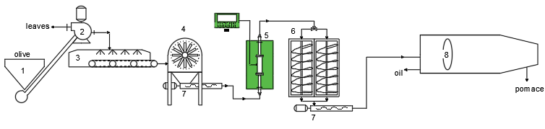
Figure 1: Layout of the plant integrated with the PEF equipment: 1 Loading hopper; 2 Defoliator; 3 Washing machine; 4 Crusher machines; 5 PEF pilot plant; 6 Malaxer group; 7 Rotor stator pumps; 8 Decanter
2.3. PEF pilot plant
The pilot plant was designed to provide maximum output while ensuring safety and ease of operation. The solid-state Marx circuit typology (Figure 2a) is a proven technology that has been used in many industrial applications. Another aspect considered was the design of the treatment chamber as, in fact, the application of high voltage in the treatment chamber is a critical component of the PEF processing system. Generator can generate unipolar pulses with voltages up to 10 kV, peak current range up to 150 A, 3.5 kW maximum output power, voltage pulse rise time of 250 ns, and frequency from 1 to 200 Hz, these parameters can only be applied to resistive loads. Generator can be controlled by a PC and the shape of pulse can be visualized from an embedded oscilloscope (Picoscope).
Solid-state Marx topology as shown in Figure 2a is a design that allows for the efficient storage and discharge of energy using relatively low voltage components. This Marx generator has been designed to be simple and cost-effective. It is composed of 12 high-voltage cells, each equipped with two insulated-gate bipolar transistor (IGBT) switches. Each cell comprises an energy storing capacitor, a pulse IGBT and a charging IGBT and diode. Capacitors Ci are charged by power supply Udc in parallel by diodes Dci and Tci IGBTs, during these period load capacitances are discharged to zero. Pulse is applied to load by connecting in series the capacitors Ci with the Tdi IGBTs. The logic control unit generates the triggering signals for all the IGBT switches, which are transmitted to each cell via optical fiber. The energy to trigger each IGBT is delivered via ring transformers, which are powered by an oscillating voltage. Galvanic insulation is ensured by toroid ferrites. Additionally, each IGBT driver has overcurrent and over-temperature protection therefore, the system's thermal conditions are well-controlled through forced-air ventilation. Front panel consists of an intuitive HMI touchscreen that provide not only error and system status messages but also real-time output voltage, current absorption, output power and pulse width.

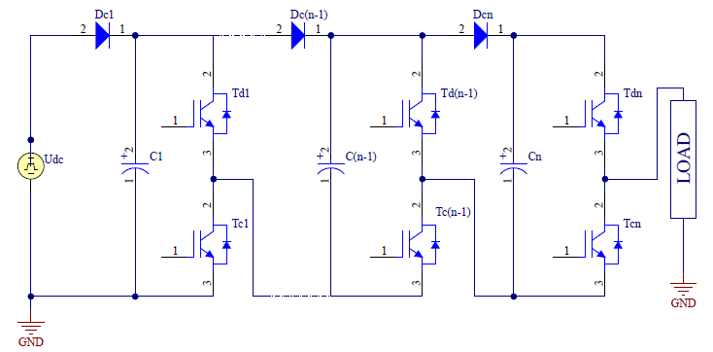  a | 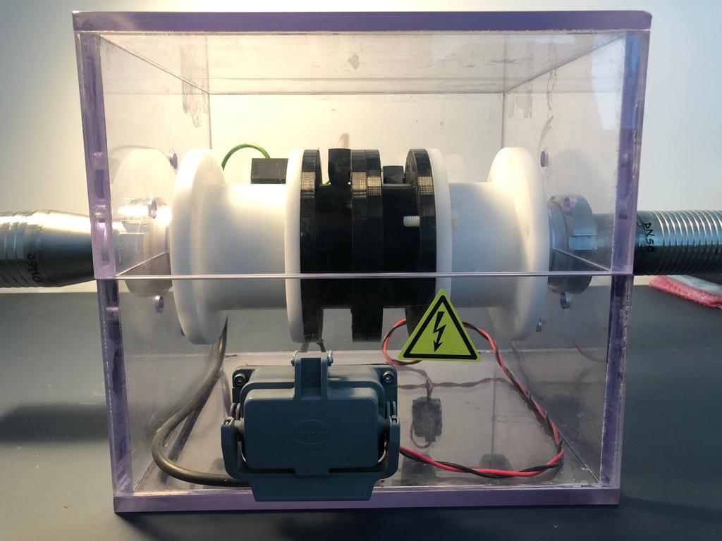  b
Figure 2: a) Modular solid-state Marx topology; b) Continuous treatment chambers
The PEF generator is designed to function continuously within a treatment chamber that can process up to a maximum of 3 tons per hour. The treatment chamber, as shown in Figure 2b, is made of polyoxymethylene material and features three tubular stainless-steel electrodes that are strategically designed for easy assembly, seamless integration with the larger plant, high wear resistance, and strict compliance with food safety standards. The electrodes are installed collinearly with two insulator spacers and 25mm distance between each electrode. The distance between the electrodes was defined to have a uniform electric field in the treatment region to allow a higher pulse energy density at the same applied voltage. The diameter of the electrodes is 40mm and 76mm, respectively, and the input and exit flanges are designed in accordance with DIN 50. The treatment chamber is incorporated into a plexiglass safety box that has a light indicator to inform workers when it is powered on and a switch that cuts the electrode's voltage in case the box is opened while it is in operation. An estimated specific energy could be calculated by the general formula:

$Ws=\frac{W*n}{V*ρ}$ (1)

where W represent pulse energy, n numbers of pulses, V the volume of treatment chamber and ρ density of material treated.
2.4. PEF equipment implementation
As shown in Figure 1 PEF equipment was installed in series with the piping that connects the crusher to the two malaxers. The programmable logic controller (PLC) was responsible for controlling the PEF unit and adjusting the operating parameters, such as voltage (V), frequency (Hz), and pulse duration (μs). By setting these parameters, the specific energy value (kJkg⁻¹) transferred to the olive paste was defined.
2.5. Experimental procedure
Experimental tests were conducted on homogenous olive batches (500 kg) and at the same processing parameters: malaxation time and temperatures were respectively of 30 min and 24 °C. The tests were carried out from plant operation in control status (PEF switch OFF) and compared with PEF unit set for different conditions (PEF switch ON): Specific Energy of 4.0 kJ kg⁻¹ and 5.0 kJ kg⁻¹; operative parameters of PEF unit for each test condition are listed in Table 1. PEF conditions were applied to two different olives varieties. Each test condition was performed five times. the decanter feed rate was 750 kg h⁻¹ without added process water.
Table 1: Operative setup of the PEF machine
Power  [W] | Pulse length  [µs] | Frequency  [Hz] | Electric field [kV cm⁻¹] | Voltage  [V cm⁻¹] | Specific Energy  [kJ kg⁻¹]
800 | 20 | 55 | 1.8 | 7200 | 4.0
1000 | 20 | 70 | 1.5 | 6000 | 5.0
2.6. Quantitative performance parameters of the plant
The quantitative performance of the plant was performed by determining: (i) the amount of oil lost in the pomace and (ii) the extractability (E). Moisture and oil content in olives and pomace has been performing according to Leone et al. (2015). E is the ratio between the percentage of oil extracted during the process and the percentage of oil contained in the olives and was detected according to Leone et al. (2018).

2.7. Statistical analysis
The quantitative results of the different theses compared were evaluated statistically with one-way analysis of variance (ANOVA) with post-hoc Tukey HSD test (p<0.05), by using MATLAB® machine learning and statistical toolboxes.
3. Results and discussion
In table 1 the results of the by-products analysis and extractability of the extraction plant are shown.
Table 2 – Quantitative results and process parameters
Olive variety | Test | Pomace |  | Extractability
 |  | Moisture  (%) | Oil  (%. db) | (%)
 | CONTROL | 64.16±1.05 a | 9.43±0.76 a | 82.02±0.54 b
Frantoio | PEF 4.0 | 63.95±1.03 a | 9.17±0.48 a | 82.30±0.86 b
 | PEF 5.0 | 63.34±0.98 a | 7.02±0.20 b | 86.07±0.30 a
 | CONTROL | 68.28±1.87 a | 12.71±0.60 a | 81.06±0.51 b
Leccino | PEF 4.0 | 68.33±1.90 a | 13.67±1.08 a | 80.12±1.60 b
 | PEF 5.0 | 69.76±1.73 a | 11.10±0.81 b | 84.30±0.50 a
Different letters in columns for each variety denote statistically significant differences (p<0.05).

Moisture content of the pomace of the Frantoio variety, revealed no significant differences between the three theses compared, with at an average value of 63.82%. The oil lost in pomace, as a percentage of dry matter, is not significant different from the PEF4.0 and the control thesis, with an average oil loss of 9.3%, while the oil lost for the PEF 5.0 thesis is significantly lower than to the other two theses compared. The best extraction performance of the PEF 5.0 thesis is confirmed by the extractability data, in fact, giving the olive paste specific energy of 5kJkg⁻¹, the extractability is 86.06%, proving to be statistically higher than the control and the PEF 4.0 thesis, these last conditions showing no significant differences in extractability (Figure 3). For Leccino variety, the trend of the data seems to be similar, in fact also in this case the moisture of pomace between the compared theses is not significant with an average value of 68.79%. No significant differences on % of oil lost in pomace were found between PEF 4.0 and the control, while a statistically significant difference was shown for PEF 5.0. Also, for the Leccino variety the extractability value is higher for the PEF 5.0 thesis compared to the other two theses. No significant differences were found between control and PEF 4.0 (Figure 3b).
Regarding the two olive varieties compared, there are differences in extractability, the Leccino variety performing worse than the Frantoio variety, probably also due to the higher maturity index.

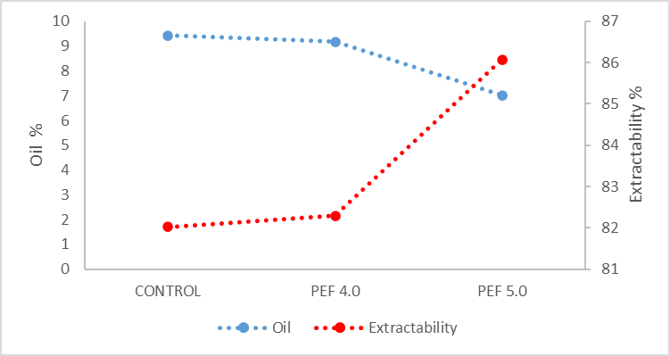  a | 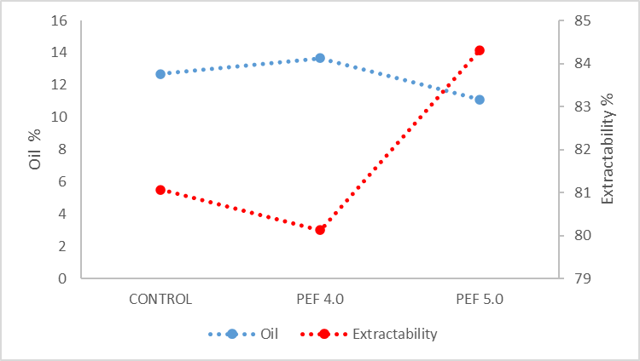  b
Figure 3: a) Oil loss in pomace (% dry matter) and extractability (%) for Frantoio variety; b) Oil loss in pomace (% dry matter) and extractability (%) for Leccino variety
This study demonstrated that also for the Frantoio and Leccino varieties the application of PEFs can increase oil extraction thus reducing the percentage of oil lost in the pomace. This research confirms the quantitative evidence already demonstrated for the Arbequina, Empeltre, Picholine, Manzanilla, Hojiblanca, Arroniz, Coratina, Nocellara del Belice, Carolea and Ottobratica varieties.
4. Conclusions
According to the obtained results, PEF technology appears to be an appropriate technology to improve the olive oil extraction process. The results demonstrated that by continuously applying a specific energy of 5.0 kJkg⁻¹ to the post-crusher olive paste, the oil extractability significantly increased compared to the control by about 4% (absolute value) for the Frantoio variety, and by about 3 % (absolute value) for the Leccino variety, while reducing the percentage of oil lost in the pomace.
However, it remains to be discovered how adjusting the PEF system operating parameters, pulse length, frequency, electric field and voltage and their combination can affect the process.
Overall, PEF technology has shown promising results for the olive oil production, although it is still a relatively new technology and more research is needed to fully understand its potential benefits and limitations.
The industrial scale-up of the prototype could have important implications in terms of cost-effectiveness of the construction and investment costs of the plant, also justified by the increase in oil yield and the limited electrical power request of the PEF plant.
However a cost-benefit analysis may be needed.Acknowledgments
The authors have contributed to the same extent to the present study.
The authors would like to thank Dr. Domenico Tarantino for the technical and laboratory support.
This work was supported by the European Union - Next Generation EU – funding from Ministry for University and Research Decree 737/2021 –research project “ECOnomia circolare, Sostenibilità e profili di evoluzione Normativa nella produzione dell’Olio extravergine Di Oliva - (ECOSNODO)” with Unique Project Code H91I21001700006.
References
Chen, Z., Zhu, S., Zhang, H., Wang, F., Marszałek, K., Zhu, Z., 2023, Multiple effects driven by pulsed electric field to enhance the catalytic efficiency of the mussel-inspired proteolytic membrane in protein hydrolysis. Chemical Engineering Journal, Volume 453, Part 2, 139792, ISSN 1385-8947.
Arshad, R.N., Abdul-Malek, Z., Munir, A., Buntat, Z., Ahmad, M.H., Jusoh, Y. M.M., Bekhit, A.E., Roobab, U., Manzoor, M.F., Aadil, R.M., 2020, Electrical systems for pulsed electric field applications in the food industry: An engineering perspective. Trends in Food Science & Technology, Volume 104, Pages 1-13, ISSN 0924-2244.
Izabelanair. 2018, The FieldFOOD project - exploring the use of pulsed electric field (PEF) technology in the food industry. The Journal of the Institute of Food Science & Technology.
Mannozzi, C., Rompoonpol, K., Fauster, T., Tylewicz, U., Romani, S., Dalla Rosa, M., Jaeger, H., 2019, Influence of Pulsed Electric Field and Ohmic Heating Pretreatments on Enzyme and Antioxidant Activity of Fruit and Vegetable Juices. Foods. 8. 247. 10.3390.
Ferreira, V. J., Arnal, A ́. J., Royo, P., García-Armingol, T., Lo ́pez-Sabiro ́n, A. M., & Ferreira, G., 2019, Energy and resource efficiency of electroporation-assisted extraction as an emerging technology towards a sustainable bio-economy in the agri- food sector. Journal of Cleaner Production, 233, 1123–1132.
Barba, F. J., Parniakov, O., Pereira, S. A., Wiktor, A., Grimi, N., Boussetta, N., Saraiva, J.A., Raso, J., Martin-Belloso, O., Witrowa-Rajchert, D., Lebovka, N., & Vorobiev, E., 2015, Current applications and new opportunities for the use of pulsed electric fields in food science and industry. Food Research International, 77, 773–798.
Barba, F. J., Zhu, Z., Koubaa, M., Sant’Ana, A. S., & Orlien, V., 2016, Green alternative methods for the extraction of antioxidant bioactive compounds from winery wastes and by-products: A review. Trends in Food Science & Technology, 49, 96–109.
Bekhit, A. E.-D. A., van de Ven, R., Suwandy, V., Fahri, F., & Hopkins, D. L., 2014, Effect of pulsed electric field treatment on cold-boned muscles of different potential tenderness. Food and Bioprocess Technology, 7, 3136–3146.
Zhou, H., Wang, Z., Dong, Y., Alhaskawi, A., Tu, T., Ezzi, S.H.A., Kota, V.G., Abdulla, M.H.A.H., Li, P., Wu, B., Chen, Y., Lu, H., 2023, New advances in treatment of skin malignant tumors with nanosecond pulsed electric field: A literature review. Bioelectrochemistry, Volume 150, 108366, ISSN 1567-5394.
Squeo, G., Tamborrino, A., Pasqualone, A., Leone, A., Paradiso, V.M., Summo, C., & Caponio, F., 2017, Assessment of the Influence of the Decanter Set-up During Continuous Processing of Olives at Different Pigmentation Index. Food Bioprocess Technol 10, 592–602.
Leone, A., Romaniello, R., Zagaria, R., Tamborrino, A., 2015, Mathematical modelling of the performance parameters of a new decanter centrifuge generation. Journal of Food Engineering, Volume 166, Pages 10-20, ISSN 0260-8774.
Tamborrino, A., Clodoveo, M., Leone, A., Amirante, P., & Paice, A., 2010, The Malaxation Process: Influence on Olive Oil Quality and the Effect of the Control of Oxygen Concentration in Virgin Olive Oil. 10.1016/B978-0-12-374420-3.00009-7.
Abenoza, M., Benito, M., Saldaña, G., Álvarez, I., Raso, J., & Sánchez Gimeno, A., 2012, Effects of Pulsed Electric Field on Yield Extraction and Quality of Olive Oil. Food and Bioprocess Technology. 6. 10.1007/s11947-012-0817-6.
Puértolas, E., & Martínez de Marañón, I., 2015, Olive oil pilot-production assisted by pulsed electric field: Impact on extraction yield, chemical parameters and sensory properties. Food Chemistry, Volume 167, Pages 497-502, ISSN 0308-8146.
Romaniello R., Tamborrino A., Leone A., 2019, Use of Ultrasound and Pef Technologies Applied to the Olive Oil Extraction Process, Chemical Engineering Transactions, 75, 13-18.
Tamborrino, A., Mescia, L., Taticchi, A., Berardi, A., Lamacchia, C.M., Leone, A., Servili, M., 2022, Continuous pulsed electric field pilot plant for olive oil extraction process. Innovative Food Science & Emerging Technologies, Volume 82, 103192, ISSN 1466-8564.
Tamborrino, A., Perone, C., Veneziani, G., Berardi, A., Romaniello, R., Servili, M., Leone, A. 2022, Experimental Investigation of a New Modular Crusher Machine Developed for Olive Oil Extraction Plants. Foods (Basel, Switzerland), 11(19), 3035.
Tamborrino, A., Urbani, S., Servili, M., Romaniello, R., Perone, C., Leone, A., 2019, Pulsed Electric Fields for the Treatment of Olive Pastes in the Oil Extraction Process. Applied Sciences. 10. 114. 10.3390/app10010114.
Veneziani, G., Esposto, S., Taticchi, A., Selvaggini, R., Sordini, B., Lorefice, A., Daidone, L., Pagano, M., Tomasone, R., Servili, M., 2019, Extra-Virgin Olive Oil Extracted Using Pulsed Electric Field Technology: Cultivar Impact on Oil Yield and Quality. Frontiers in Nutrition, 6,134.
Navarro, A., Ruiz-Méndez, M. V., Sanz, C., Martínez, M., Rego, D., Pérez, A. G., 2022, Application of Pulsed Electric Fields to Pilot and Industrial Scale Virgin Olive Oil Extraction: Impact on Organoleptic and Functional Quality. Foods (Basel, Switzerland), 11(14).
Leone, A., Tamborrino, A., Esposto, S., Berardi, A., Servili, M., 2022, Investigation on the Effects of a Pulsed Electric Field (PEF) Continuous System Implemented in an Industrial Olive Oil Plant. Foods 11, no. 18: 2758.
Martínez-Beamonte, R., Ripalda, M., Herrero-Continente, T., Barranquero, C., Dávalos, A., López de Las Hazas, M. C., Álvarez-Lanzarote, I., Sánchez-Gimeno, A. C., Raso, J., Arnal, C., Surra, J. C., Osada, J., Navarro, M. A., 2022, Pulsed electric field increases the extraction yield of extra virgin olive oil without loss of its biological properties. Frontiers in Nutrition, 9, 1065543.

